Preliminary Plans for a Yoga Vacation with Lynn Shuck in Punta Mita, November 2-8, 2019
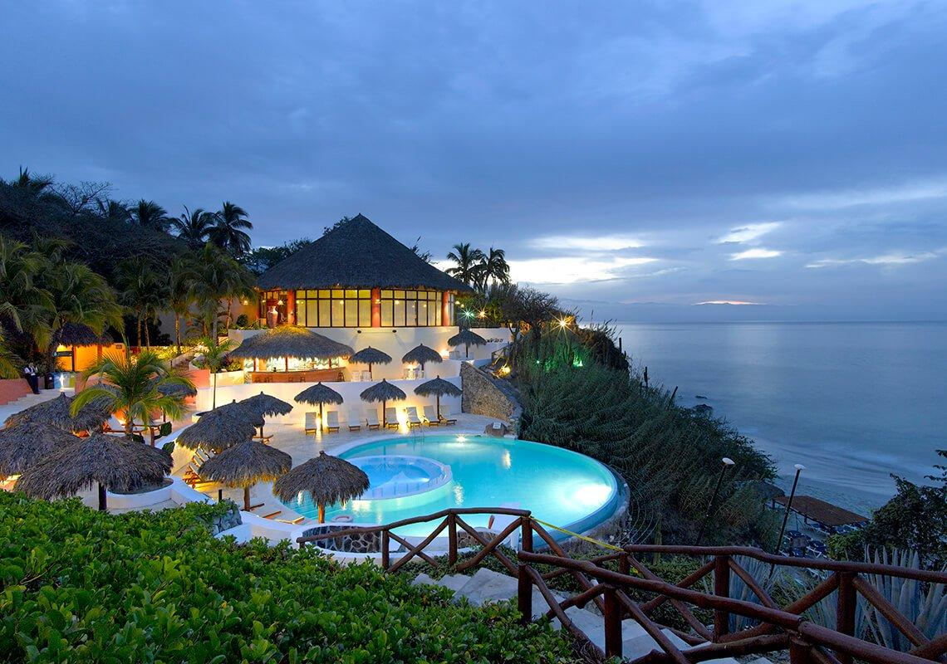 | Plans are coming together for a 7-day, 6-night yoga retreat, November 2-8, 2019, at a 4-star, all-inclusive resort in the Punta Mita area of Mexico (flying into Puerto Vallarta). Lynn will teach 2 sessions daily, limited to 20 participants, leaving ample time for relaxation and exploration. Non-yoga participants are welcome to come as guests.  If you are very likely interested, send an email ASAP to yogaretreatwithlynn@gmail.com . Details about the hotel, accommodations, etc. will be available to everyone AFTER we get an idea of how many people are seriously interested. Direct all questions to yogaretreatwithlynn@gmail.com
Both single- and double-occupancy rooms will be available. Estimated costs for the week, per person, will be $800-1,000. This includes all taxes, gratuities, and all food and beverages while in the resort. Airfare is not included. Non-participants in the yoga sessions are welcome and would not count among the 20 participants. Group airfare rates may be a possibility from Minneapolis/St. Paul airport, but rates and arrangements for group discounts cannot be determined until 11 months before departure.
Details about the deposit, the date for final payment, and conditions for refunds of deposits will be provided later. All payments will be handled by check or a PayPal account linked to a credit card or bank account.

